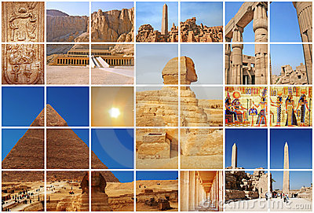  - Ancient egypt  “the gift  OF the nile”  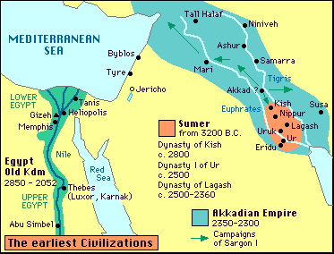 |  | The Nile River!  The Pyramids!  Mummies!  Hieroglyphics!  Gods & Goddesses!

Ancient Egypt: People

Menes: _____________________________________________________________________________________________________________________________________________________________________________________________________________________________________________________________________

Khufu:
_____________________________________________________________________________________________________________________________________________________________________________________________________________________________________________________________________

Jean Champollion:
_____________________________________________________________________________________________________________________________________________________________________________________________________________________________________________________________________

Ahmose I:
_____________________________________________________________________________________________________________________________________________________________________________________________________________________________________________________________________

Amenhotep I:
_____________________________________________________________________________________________________________________________________________________________________________________________________________________________________________________________________

Hatshepsut:
_____________________________________________________________________________________________________________________________________________________________________________________________________________________________________________________________________

Akhenaton:
_____________________________________________________________________________________________________________________________________________________________________________________________________________________________________________________________________

Ramses II:
_____________________________________________________________________________________________________________________________________________________________________________________________________________________________________________________________________

Piye:
_____________________________________________________________________________________________________________________________________________________________________________________________________________________________________________________________________

Tutankhamun (King Tut):
_____________________________________________________________________________________________________________________________________________________________________________________________________________________________________________________________________

Ancient Egypt: VOCABULARY

delta: _____________________________________________________________________________________________________________________________________________________________________________________________________________________________________________________________________

unification:
_____________________________________________________________________________________________________________________________________________________________________________________________________________________________________________________________________

pharaoh:
_____________________________________________________________________________________________________________________________________________________________________________________________________________________________________________________________________

Old Kingdom:
_____________________________________________________________________________________________________________________________________________________________________________________________________________________________________________________________________

mummification:
_____________________________________________________________________________________________________________________________________________________________________________________________________________________________________________________________________

pyramid:
_____________________________________________________________________________________________________________________________________________________________________________________________________________________________________________________________________

hieroglyphics:
_____________________________________________________________________________________________________________________________________________________________________________________________________________________________________________________________________

papyrus:
_____________________________________________________________________________________________________________________________________________________________________________________________________________________________________________________________________

economy:
_____________________________________________________________________________________________________________________________________________________________________________________________________________________________________________________________________

expedition:
_____________________________________________________________________________________________________________________________________________________________________________________________________________________________________________________________________

cataract:
_____________________________________________________________________________________________________________________________________________________________________________________________________________________________________________________________________

social pyramid:
_____________________________________________________________________________________________________________________________________________________________________________________________________________________________________________________________________

Social Pyramid of Meroë, Capital of Kush
(Our World Textbook, Chapter 3, Lesson 4)

Merchants, Artisans, and Farmers
King or Queen
Ancient Egypt’s Social Pyramid According to
Kids Discover Magazine, “Ancient Egypt”

Farmers and Laborers
District Governors
Viziers/High Priests

